|  |
| --- |
| Qin luo  Shanghainese · Female · 1981.9  18521539064  Luoqin_bob@hotmail.com / lizzieluo@163.com |
| * Solid and rich skills and knowledge of UI/web developing & testing. * Experience of tech leader, able to build the team. * Experience of production development and release. * Worked for many famous brands/companies, helped them to setup official / production /  e-commerce websites. |

# Experience

|  |
| --- |
| 2011.11 – nowSr. Developer, sap labs Worked for DNA dept. in my first five years in SAP, and later for IOT SCN dept. till now.   * In DNA, HANA Innovation dept., I built and leaded the team to design and develop APPs based on HANA platform. Helped sales to promote HANA relates. Obtained the very good feedback from sales and consultants. Meanwhile, used big sample data from Telcom, manufacturing and FMCG to develop and prove the possible scenario for HANA in the future. * In SCN dept., I am in charge of IOT production development, testing and release. As the core dev and UI arc, use SAP standard packages, plugins and tools, including SAPUI5, OData, NodeJS, Gulp, Karma, Mocha, Selenium, Sonar, Approuter, etc. to develop, build, deploy APPs to Cloud, and reach kinds of quality checks. |
| 2011sr. developer, wipro Developed the official websites of famous brands. |
| 2008 – 2010sr. HTML developer, nurun Developed and maintained the e-commerce websites for famous global cosmetics company. |
| 2007developer, grey (4a)  * Developed websites for brands promotion, campaigns and events. * Developed BBS for famous FMCG firm. |
| 2005 – 2007developer, p2a Developed HR system based on ASP.NET. |
| 2002 – 2004editor & developer, chuying tech In charge of portals editing and monitoring. |

# Education

|  |
| --- |
| bachelor, fudan university | mis |

# screenshots of my works

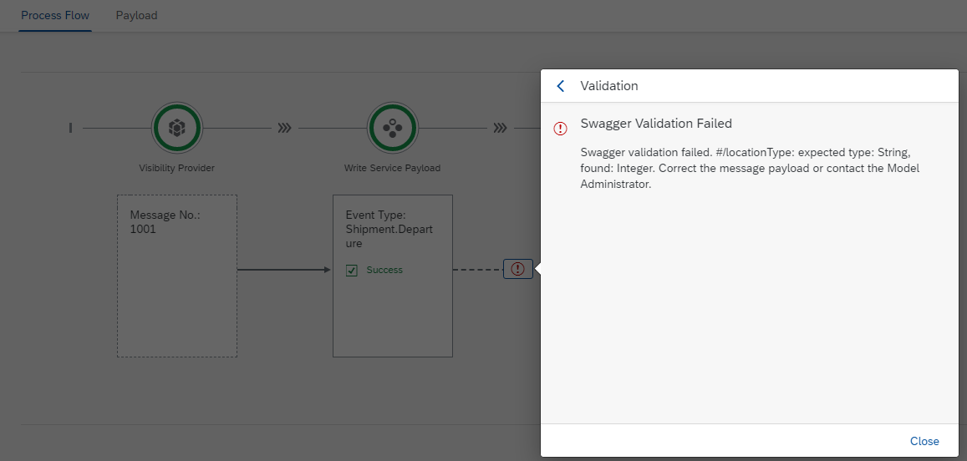

Figure 1 – process flow of Message logs

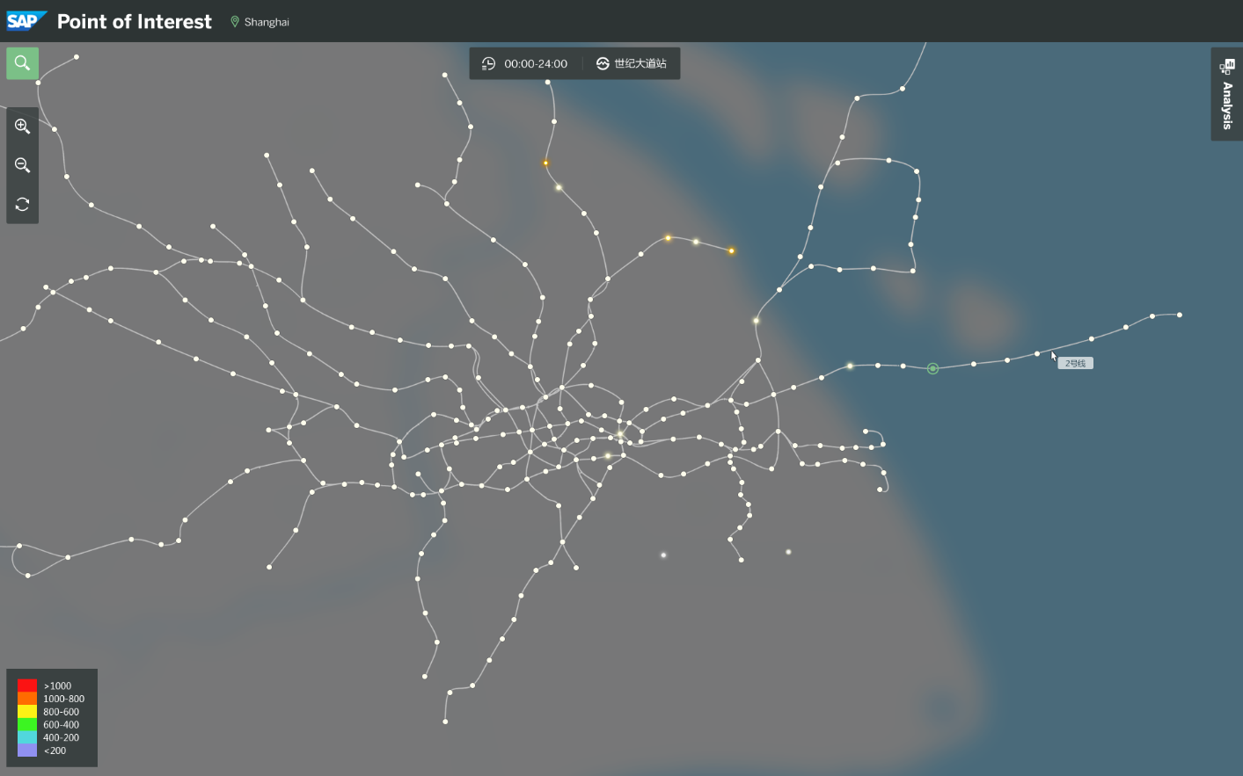

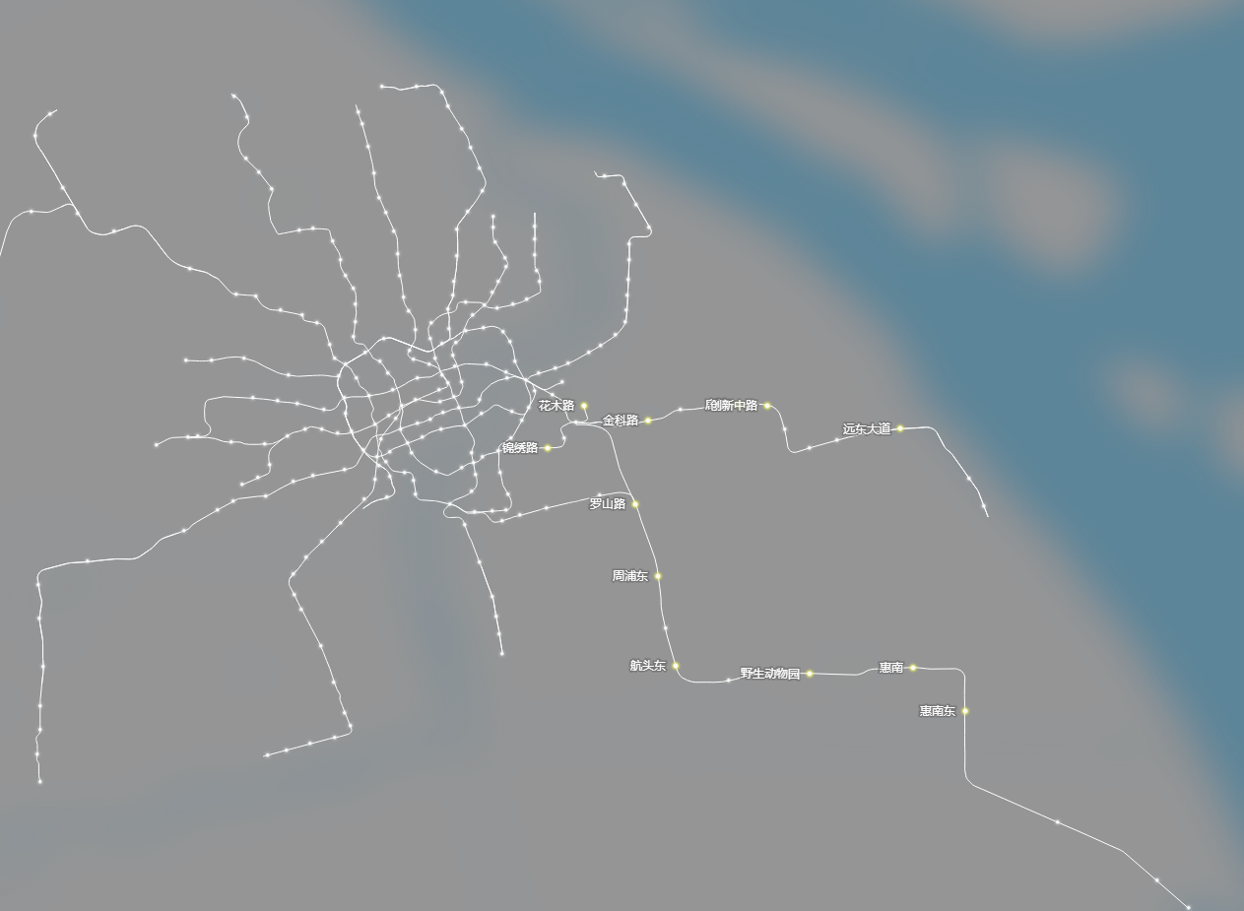

Figure 2&3 – Hot words of Shanghai Metro